**EBS and CPU in EC2**

Amazon Elastic Block Store (EBS) is a storage service used with EC2 instances, while the CPU of an EC2 instance determines its processing power.

**Login to AWS Console:** Go to [AWS Console](https://aws.amazon.com/) and sign in.

**Navigate to EC2:** Click on **EC2** under the **Compute** section.

**Launch Instance:**

* Click **Launch Instance**.
* Choose an Amazon Machine Image (AMI) Amazon Linux
* Select an **Instance Type** (e.g., t2.micro for free tier).
* 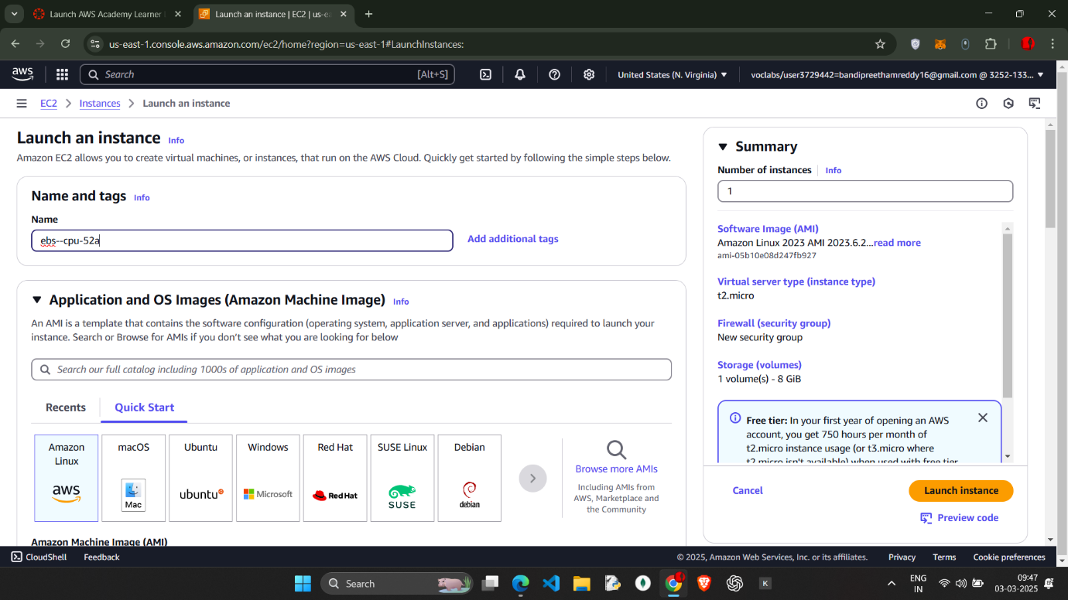

Created instance with name ebs—cpu—52a ( all should be in lower case)

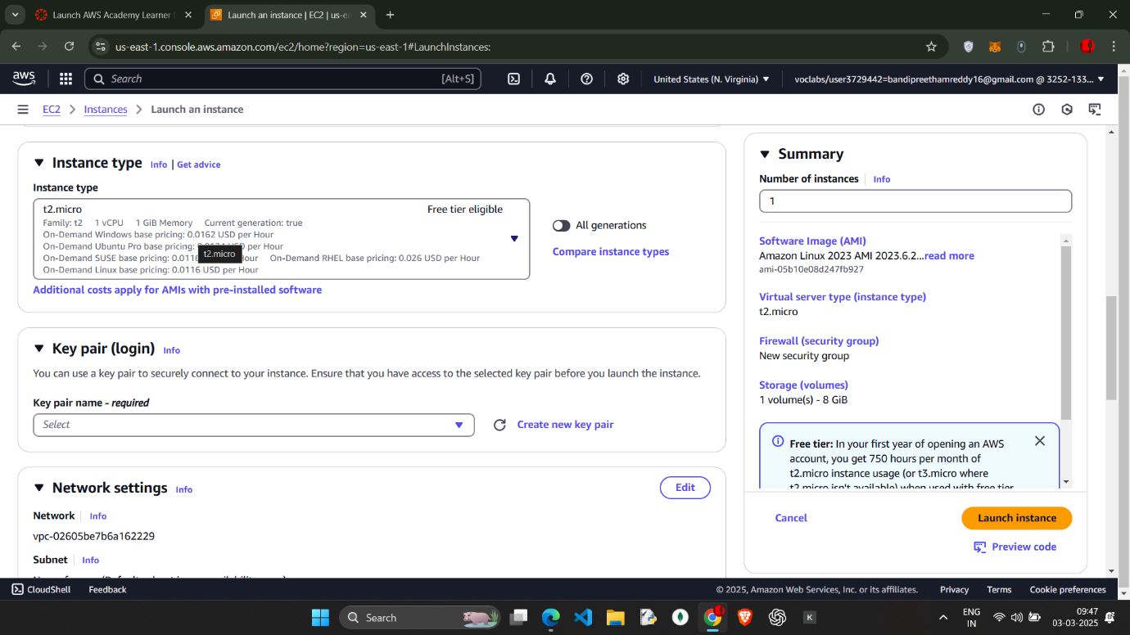

T2micron 1 cpu 1memory

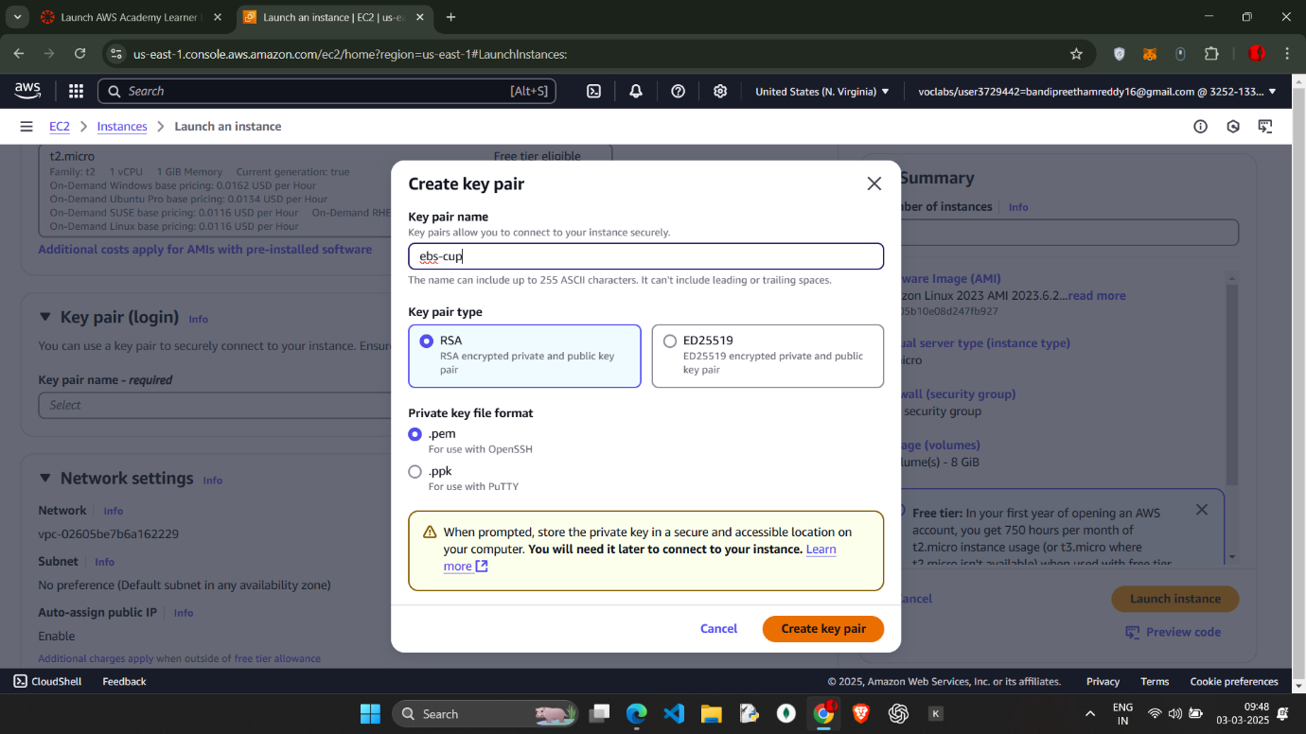

Create key pair .pem

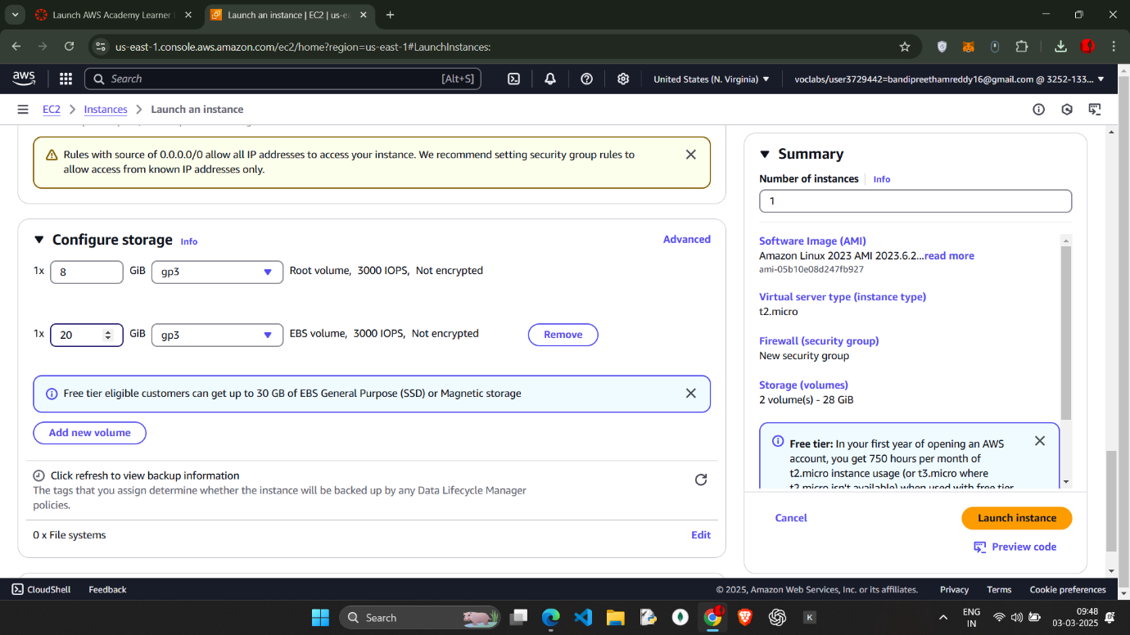

Add new volume 20 gb which is EBS volume (not encrypted)

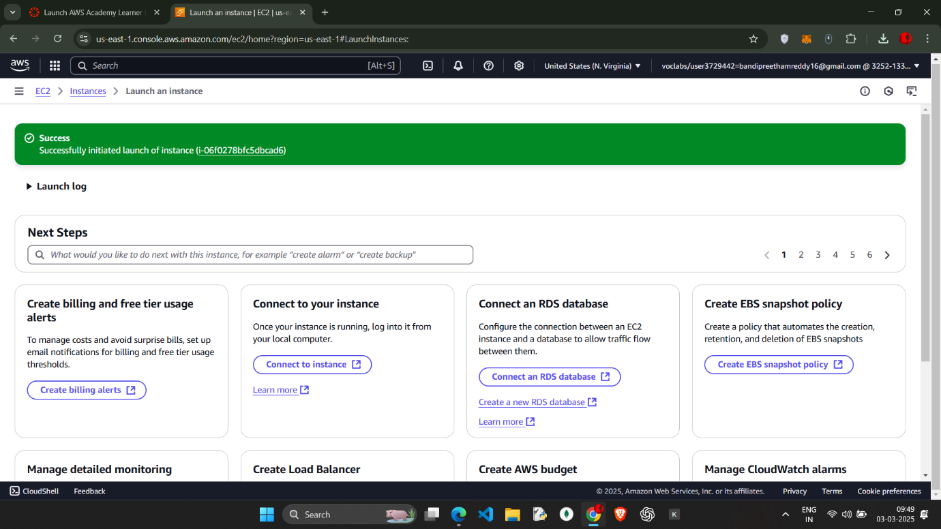

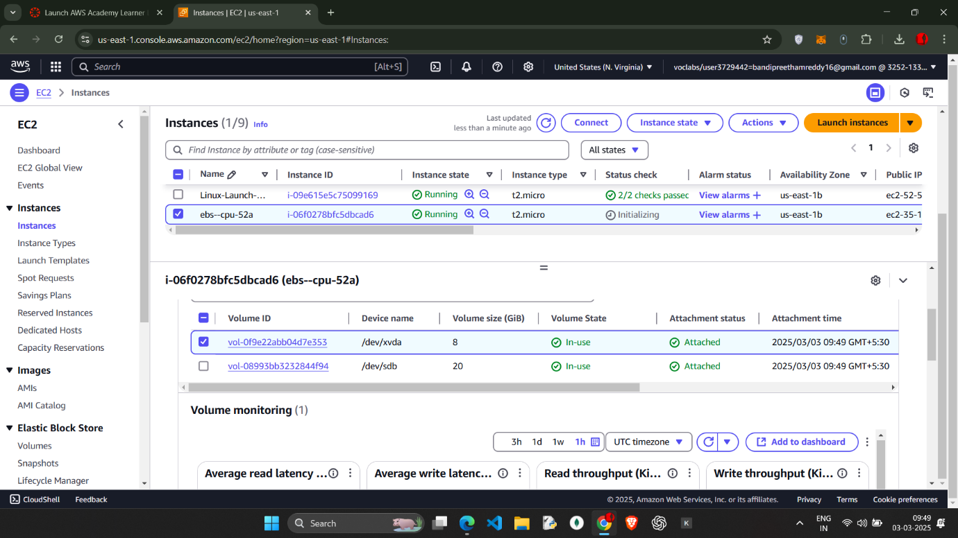

We can observe that the instance type is t2.micro

We need to stop the instance and change the type of instance

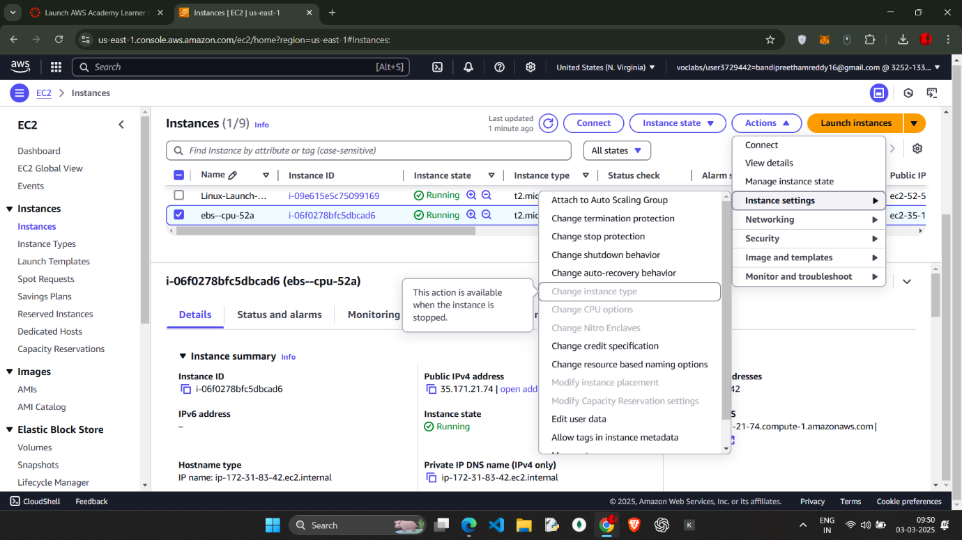

We cant change it while running we need to stop and change the instance type to t2.medium

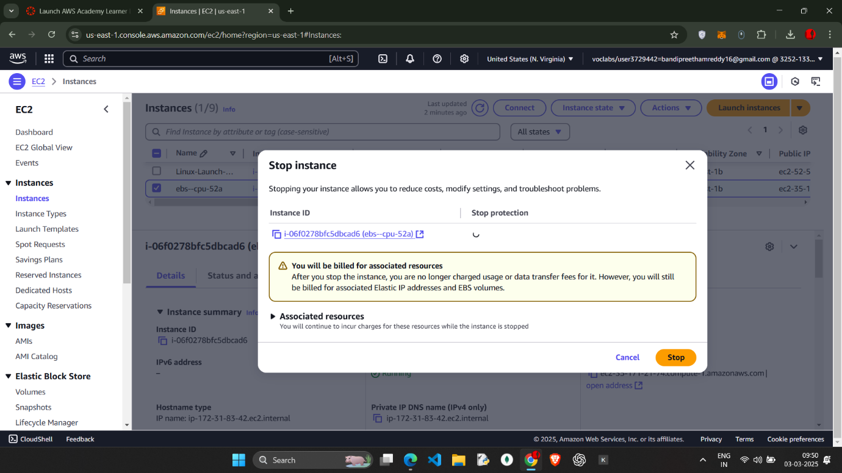

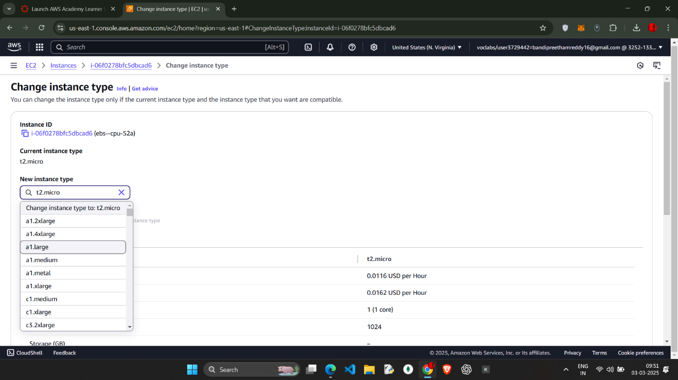

Select the t2.medium as instance type

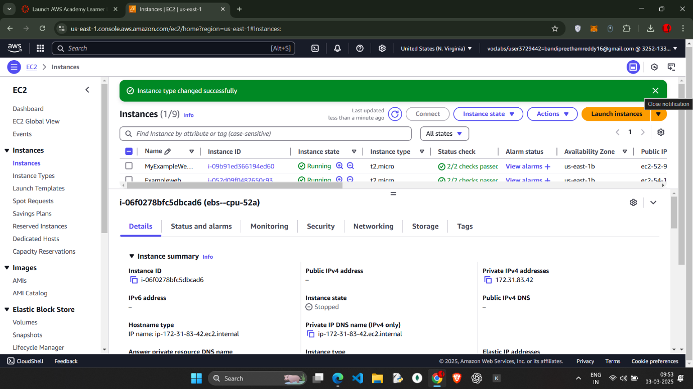



instance type change (we need to change the instance type according to the needs)

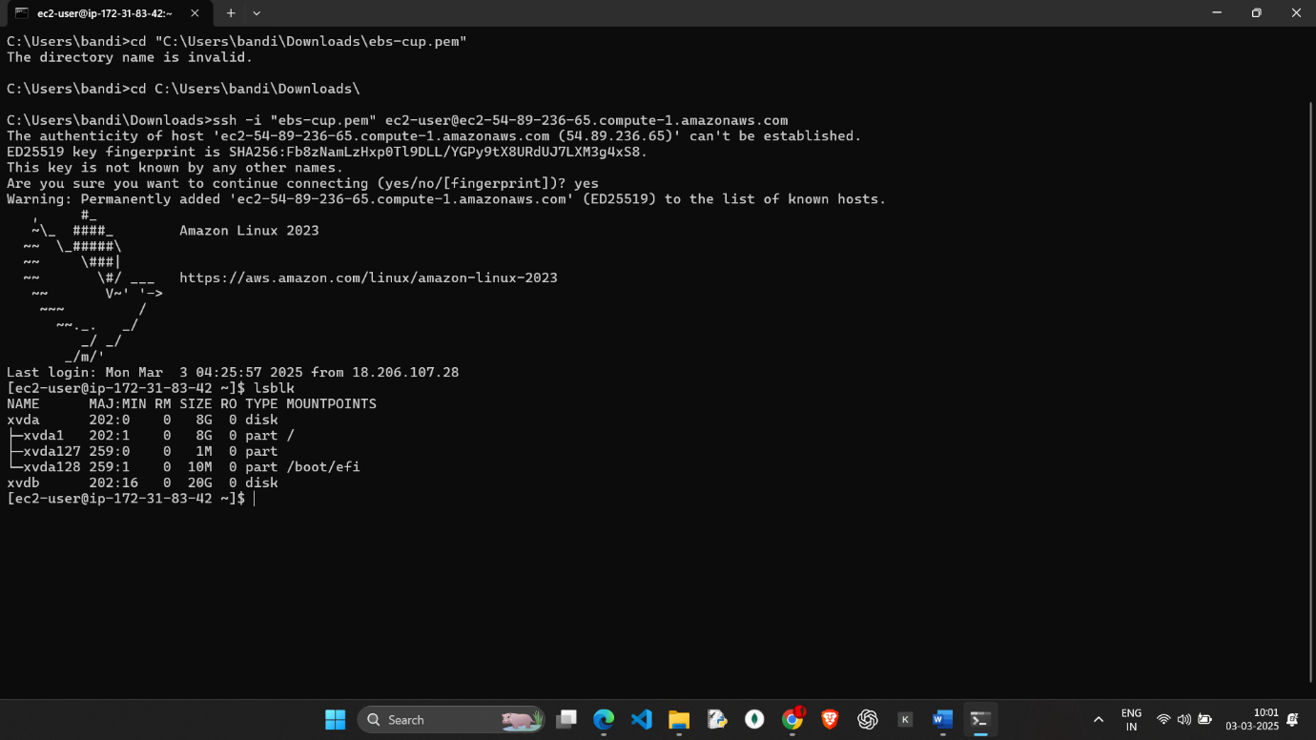

Commands lsblk we will get the extra volume we added before …..

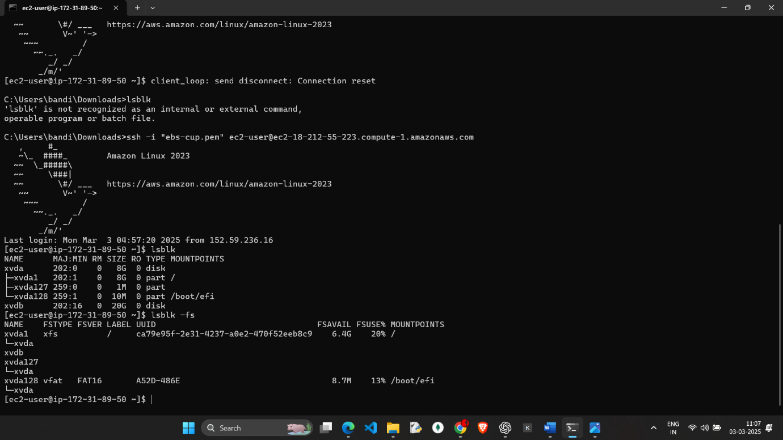

ende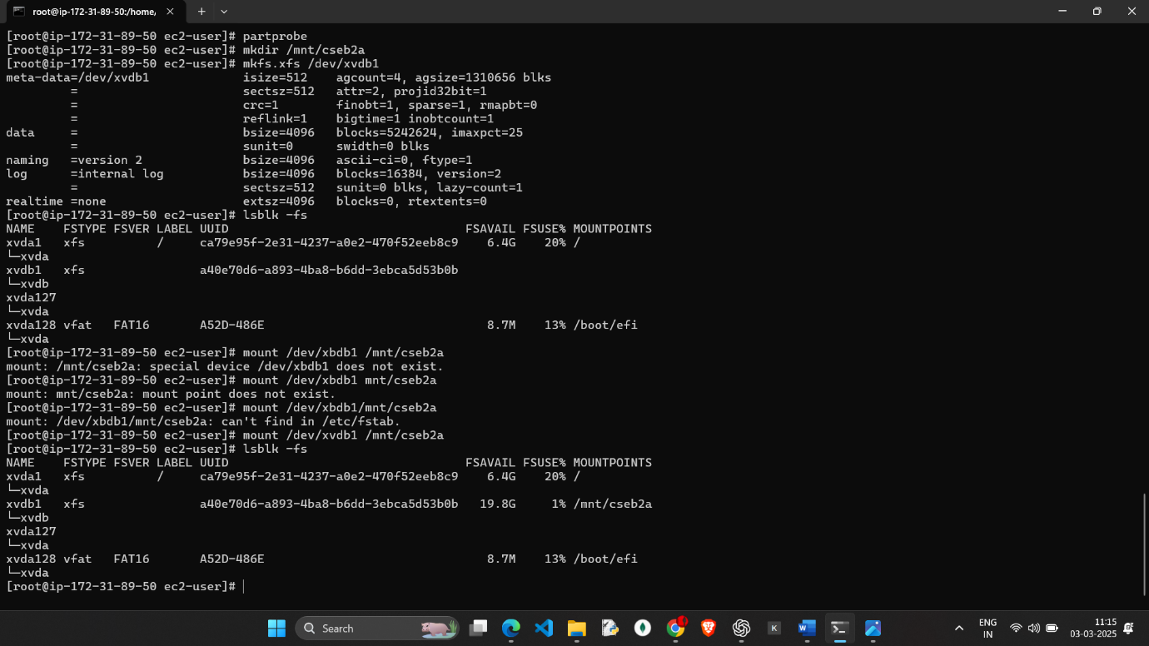

enter command lsblk -fs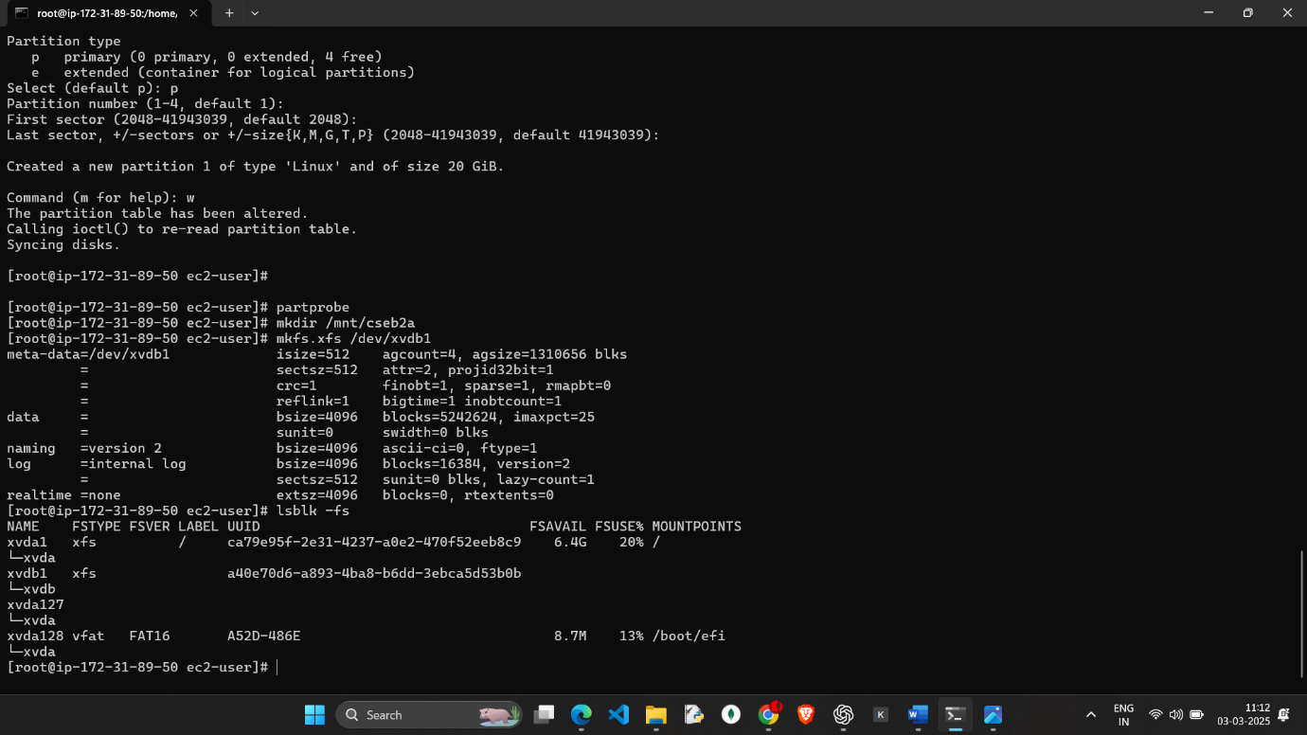sselect 